RoleHistory，存储在hdfs中，格式如下：

{

"entry": {

"org.apache.slider.server.avro.RoleHistoryHeader": {

"version": 1,

"saved": 1473581684760,

"savedx": "15718501818",

"savedate": "11 Sep 2016 08:14:44 GMT",

"roles": 3

}

}

}{

"entry": {

"org.apache.slider.server.avro.RoleHistoryMapping": {

"rolemap": {

"slider-appmaster": 0,

"SUPERVISOR": 4,

"NIMBUS": 1

}

}

}

}{

"entry": {

"org.apache.slider.server.avro.NodeEntryRecord": {

"host": "sgserver006",

"role": 1,

"active": false,

"last_used": 0

}

}

}{

"entry": {

"org.apache.slider.server.avro.NodeEntryRecord": {

"host": "sgserver005",

"role": 1,

"active": true,

"last_used": 1473577051549

}

}

}{

"entry": {

"org.apache.slider.server.avro.RoleHistoryFooter": {

"count": 2

}

}

}

LoadedRoleHistory

|  |  |  |
| --- | --- | --- |
| 成员变量 | 变量成员 | 描述 |
| header:RoleHistoryHeader | version |  |
| saved | save时间 |
| savedx,savedata | Save标签 |
| roles | 启动了几种roles |
| roleMap:Map<String,Map> |  | 每种组件的启动个数 |
| Records:List<NodeEntryRecord> | host | 组件启动主机 |
|  | role | 组件名称 |
|  | active | 作用是什么？是否可利用下 |
|  | last_used | 时间 |

初始化过程：

SliderAppMaster#createAndRunCluster

—> AppState#buildInstance

—>RoleHistory#onStart

#onThraw

—>RoleHistoryWriter#loadFromHistoryDir //cluster/history目录中

PlacementPolicy

|  |  |
| --- | --- |
| Placement values | 描述 |
| NONE | 默认使用Anti-affinity |
| DEFAULT | 值为NONE |
| STRICT | 调度到原节点 |
| ANYWHERE | 没有数据本地性，可以启动在任何地方 |
| ANTI_AFFINITY_REQUIRED | 强制使用AA调度 |
| EXCLUD_FROM_FLEXING |  |

PlacementPolicy的使用

ResourceKeys#COMPONENT_PLACEMENT_POLICY

yarn.component.placement.policy

SliderAMClientProvider#

—> ROLES:List<ProviderRole>

APPMASTER <=

COMPONENT_AM,

PlacementPolicy_EXCLUDE_FROM_FLEXING

ProviderRole#

AppState#buildRoleRequirementsFromResources

#createDynamicProviderRole

<= rolename

<= component:MapOperations <= confTree.components.get(name)

yarn.api.records.getPriority

SliderAppMaster调度分析

#onContainersAllocted <= allocatedContainers:List<Container>

#AppState.onContainerAllocated <= allocatedContainers,assignments,operation

#launchServer.launchRole(assignment,instanceDefinition)

"yarn.component.placement.policy":"1" <— STRICT

测试结果：

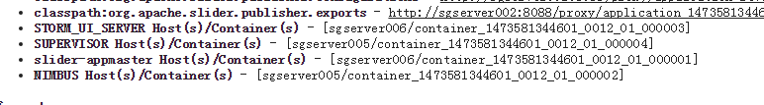

停掉sgserver005上的节点后，

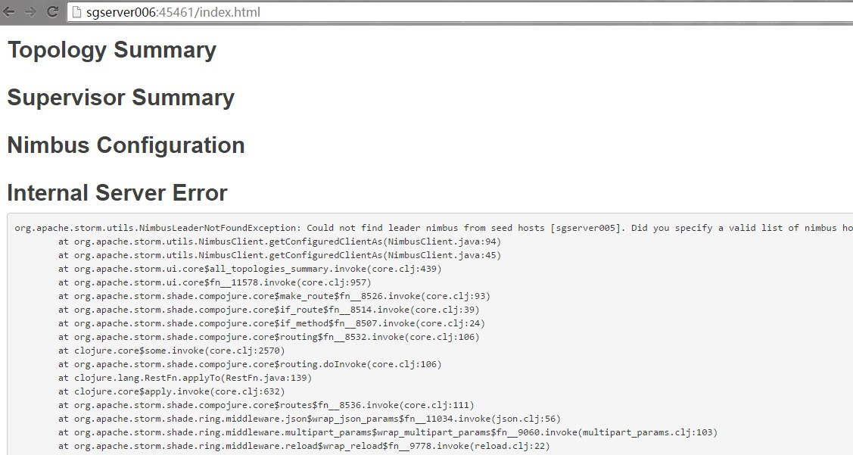

Nimbus服务异常

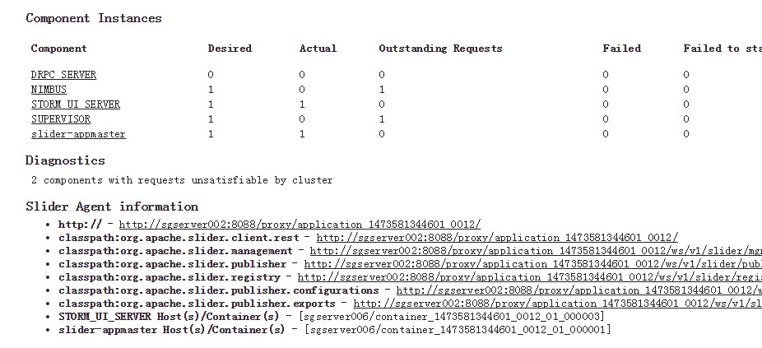

停掉以后再次启动结果相同，恢复节点server005

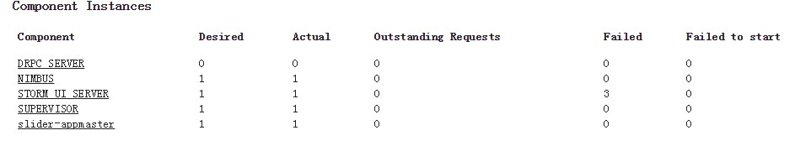

参考链接：

http://slider.incubator.apache.org/design/rolehistory.html